Name: __________________________________________________ Period: _______________ Science 7

Modeling Mitosis

Objective: To demonstrate that cells repeatedly divide to make more cells for growth and repair. Also, students will be able to recreate the phases of mitosis using Oreo cookies.

Background Information: Mitosis is the process of cell division which results in the production of two daughter cells from a single parent cell. The daughter cells are identical to one another and to the original parent cell. There are 5 main steps in cell division: interphase, prophase, metaphase, anaphase, telophase. Interphase involves the duplication of DNA. In this lab, we will only be working with the last four phases. These phases make up MITOSIS: (prophase, metaphase, anaphase, and telophase).

Materials:

- 4 Oreo cookies
- Ice cream sprinkles
- Brown paper towel
- Pencils

Procedure:

- With a partner, get some sprinkles, paper towel, and 4 cookies.

- Twist the cookies apart very carefully so that you have 4 sides with cream and 4 sides without cream.

- The cookie & cream will represent a cell; the ice cream sprinkles will represent chromosome pairs, spindle fibers, and centrioles. (any colors will work for each part)

- Use the cookie and the sprinkles to make models of the following phases of cell mitosis:

  - Prophase
  - Metaphase
  - Anaphase
  - Telophase

- When complete, have your teacher check your models.

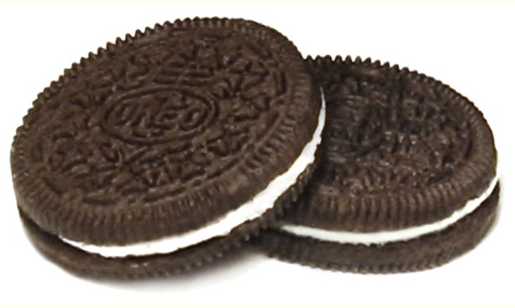
- Diagram & label your models in the data section.

Data Table

Mitosis Phases | Diagram | Description
Prophase
Metaphase
Anaphase
Telophase

Critical Thinking Writing Assignment:

1. Write a paragraph summarizing why is mitosis important. Discuss the importance of cell division and provide an example where cell division is necessary.
__________________________________________________________________________________________________________________________________________________________________________________________________________________________________________________________________________________________________________________________________________________________________________________________________________________________________________________________________________________________________________________________________________________________________________________________________________________________________________________________________________________________________________________________________________________________________________________________________________________________________________

