Name: ______________________________________________ Period: ______________ Science 7

Lab # ______ The Menstrual Cycle Lab
(why not call it a womenstual cycle? ha)

Who has a menstrual cycle?
Women can start their menstrual cycle in their early teen years, typically between the ages of 11 and 14. The menstrual cycle stops when a woman reaches menopause, around age 50.

What is a menstrual cycle?

The menstrual cycle is the series of changes a woman's body goes through to prepare for pregnancy. About once a month, the uterus grows a new lining to get ready for a fertilized egg . When there is no fertilized egg to start a pregnancy, the uterus sheds its lining. This causes menstrual bleeding, otherwise known as a period.
The menstrual cycle starts at Day 1 of bleeding and ends the next time bleeding occurs. The average menstrual cycle is 28 days long.
Ovulation is a part of the menstrual cycle. In ovulation an egg is released by a mature ovarian follicle. The egg then travels down the fallopian tubes towards the uterus. Pregnancy can only occur during ovulation. Ovulation occurs only once in every menstrual cycle, usually between days 12 – 16. Some females can tell they are ovulating because they have a spike in body temperature. The average body temperature is kept at 98.6°, during ovulation it can raise up to 99.7° or higher. Remember, pregnancy can only occur during ovulation.
Pregnancy occurs when the egg becomes fertilized by sperm. The sperm enters the female’s body due to sexual intercourse. Once the egg is fertilized menstrual bleeding will stop. The cycle continues again following pregnancy and childbirth.

What controls the menstrual cycle?

Hormones control a menstrual cycle. During each cycle, the brain's hypothalamus and pituitary gland send hormone signals back and forth to the ovaries. These signals get the ovaries and uterus ready for a pregnancy.
The hormones estrogen and progesterone play the biggest roles in how the uterus changes during each cycle.
- Estrogen builds up the lining of the uterus.

- Progesterone increases after an ovary releases an egg (ovulation) at the middle of the cycle. This helps the estrogen keep the lining thick and ready for a fertilized egg.

- A drop in progesterone (along with estrogen) causes the lining to break down. This is when menstrual bleeding or a period starts.
Part A. Questions

- At what age does the menstrual cycle begin?

- How long is an average menstrual cycle?

- What causes menstrual bleeding?

- What is ovulation?

- How can a female tell if she is ovulating?

- What causes menstrual bleeding to stop?

- What causes pregnancy?

- How does estrogen effect the menstrual cycle?

- How does progesterone effect the menstrual cycle?

- What glands control hormone production?

Part B. Anatomy
- Review the anatomy of the human female reproductive system.
- Labeling the diagram with the following terms:
- ovary: the female reproductive organ in which eggs are produced. It also acts as a gland and secretes estrogen and progesterone sex hormones.

- uterus (womb): the muscular organ in which a fetus develops and is nurtured during pregnancy.

- uterus lining: the inner tissue in the uterus which builds up in preparation for the implantation of a fertilized egg. It is rich in blood vessels to nurture the embryo.

- egg (ovum): female sex cell with one copy of the mother’s genes.

- Fallopian tube (oviduct): two very thin tubes that serve as a path for the egg from the ovaries to the uterus.

- vagina: muscular tube that serves as the birth canal for delivering the baby from the uterus (womb) to the outside world.

- follicle: tissue in ovary surrounding developing egg. The follicle cells are the cells of the ovary that secrete the hormone, estrogen.

- cervix: opening of the uterus that leads to the vagina. vagina. During birth, the cervix must dilate enough (up to 10 cm or ~4 inches) to allow the baby to pass through.
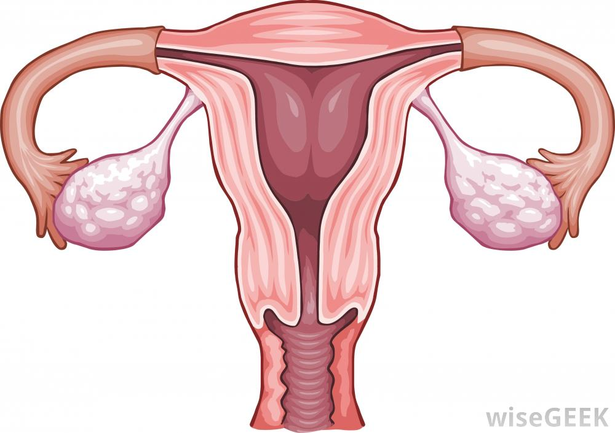

follicle

uterus lining

Part C. The Calendar of the Menstrual Cycle

In this section we will explore the events of the menstrual cycle across a calendar month to relate the internal stages of the menstrual cycle to the days of the month.

1. Menstrual Cycle: No Fertilization of Egg

- At the back of this packet you will find a series of symbols in squares labeled Figure 2A. “No Fertilization of Egg”. These diagrams show different stages that occur during the menstrual cycle if fertilization does not occur.

- Look over the calendar marked Figure 2B. It describes the series of events that take place in the female reproductive system if fertilization does not occur.

- Cut out the squares from Figure 2A and match them with the events on the calendar. Place the square to the right of the bracket (in an empty day) for the event that properly describes it.

Note: Not all calendar boxes will be filled in.

- When all squares have been properly matched to events, tape them onto the calendar in their proper location.

2. Menstrual Cycle: Fertilization of Egg Does Occur

- At the back of this packet you will find a series of symbols in squares labeled Figure 3A. “Fertilization of Egg”. These diagrams show different stages that occur during the menstrual cycle if fertilization does occur.

- Look over the calendar marked Figure 3B. It describes the series of events that take place in the female reproductive system if fertilization does occur.

- Cut out the squares from Figure 3A and match them with the events on the calendar. Place the square to the right of the bracket (in an empty day) for the event that properly describes it.

Note: Not all calendar boxes will be filled in.

- When all squares have been properly matched to events, tape them onto the calendar in
their proper location.

Figure 2B. Day By Day Changes In The Menstrual Cycle: No Fertilization of Egg
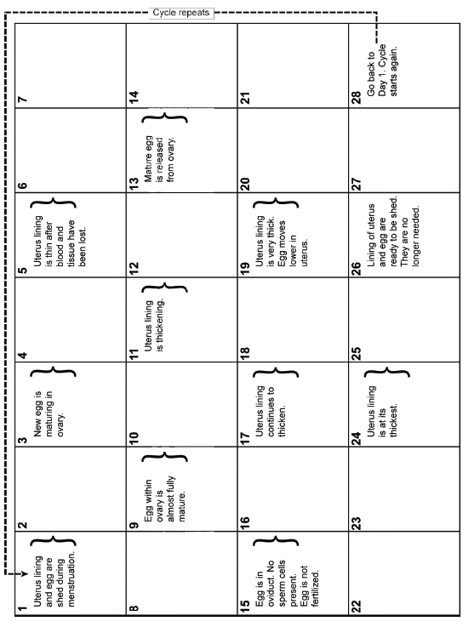

Figure 3B. Day By Day Changes In The Menstrual Cycle: Fertilization of Egg

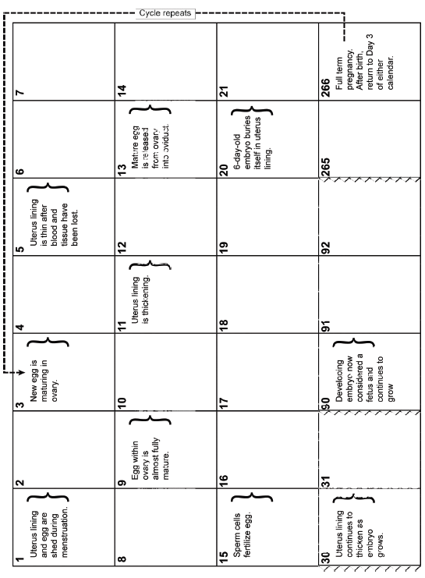

Figure 2A. No Fertilization of Egg
Cut out individual boxes and place on the appropriate empty date on the accompanying calendar labeled, “Figure 2B. Day By Day Changes In The Menstrual Cycle: No Fertilization of Egg”.

NOTE: Do not paste over the days with writing in them. Paste into the empty day next to the
correct description.

Figure 3A. Fertilization of Egg
Cut out individual boxes and place on the appropriate empty date on the accompanying calendar labeled, “Figure 3B. Day By Day Changes In The Menstrual Cycle: Fertilization of Egg”.

NOTE: Do not paste over the days with writing in them. Paste into the empty day next to the
correct description.

