Name: __________________________________________ Living Environment Lab
Lab # ______ Lab Safety and Tools
Part 1: Safety in the Biology Laboratory
Working in the biology laboratory can be interesting, exciting, and rewarding. But it can also be quite dangerous if you are not serious and alert and if proper safety precautions are not taken at all times. You are responsible for maintaining an enjoyable, instructional, and safe environment in the biology laboratory. Unsafe practices endanger not only you but the people around you as well. Read the following information about safety in the biology laboratory carefully. Review applicable safety information before you begin each Laboratory Investigation. If you have any questions about safety or laboratory procedures, be sure to ask your teacher.

Science Safety Rules
One of the first things a scientist learns is that working in the laboratory can be an exciting experience. But the laboratory can also be quite dangerous if proper safety rules are not followed at all times. To prepare yourself for a safe year in the laboratory, read over the following safety rules. Then read them a second time. Make sure you understand each rule. If you do not, ask your teacher to explain any rules you are unsure of.

Dress Code
1. Many materials in the laboratory can cause eye injury. To protect yourself from possible injury, wear safety goggles whenever you are working with chemicals, burners, or any substance that might get into your eyes. Never wear contact lenses in the laboratory.
2. Wear a laboratory apron or coat whenever you are working with chemicals or heated substances.
3. Tie back long hair to keep your hair away from any chemicals, burners and candles, or other laboratory equipment.
4. Remove or tie back any article of clothing or jewelry that can hang down and touch chemicals and flames. Do not wear sandals or open-toed shoes in the laboratory. Never walk around the laboratory barefoot or in stocking feet.

General Safety Rules
5. Be serious and alert when working in the laboratory. Never “horse around” in the laboratory.
6. Be prepared to work when you arrive in the laboratory. Be sure that you understand the procedure to be employed in any laboratory investigation and the possible hazards associated with it.
7. Read all directions for an investigation several times. Follow the directions exactly as they are written. If you are in doubt about any part of the investigation, ask your teacher for assistance.
8. Never perform activities that are not authorized by your teacher. Obtain permission before “experimenting” on your own.
9. Never handle any equipment unless you have specific permission.

10. Take extreme care not to spill any material in the laboratory. If spills occur, ask your teacher immediately about the proper cleanup procedure. Never simply pour chemicals or other substances into the sink or trash container.
11. Never eat or taste anything or apply cosmetics in the laboratory unless directed to do so. This includes food, drinks, candy, and gum, as well as chemicals. Wash your hands before and after performing every investigation.
12. Know the location and proper use of safety equipment such as the fire extinguisher, fire blanket, first-aid kit, safety shower, and eyewash station.
13. Notify your teacher of any medical problems you may have, such as allergies or asthma.
14. Keep your laboratory area clean and free of unnecessary books, papers, and equipment.

First Aid
15. Report all accidents, no matter how minor, to your teacher immediately.
16. Learn what to do in case of specific accidents such as getting acid in your eyes or on your skin. (Rinse acids off your body with lots of water.)
17. Become aware of the location of the first aid kit. Your teacher should administer any required first aid due to injury. Or your teacher may send you to the school nurse or call a physician.
18. Know where and how to report an accident or fire. Find out the location of the fire extinguisher, phone, and fire alarm. Keep a list of important phone numbers such as the fire department and school nurse near the phone. Report any fires to your teacher at once.

Heating and Fire Safety
19. Never use a heat source such as a candle or burner without wearing safety goggles.
20. Never heat a chemical you are not instructed to heat. A chemical that is harmless when cool can be dangerous when heated.
21. Maintain a clean work area and keep all materials away from flames.
22. Never reach across a flame.
23. Make sure you know how to light a Bunsen burner. (Your teacher will demonstrate the proper procedure for lighting a burner.) If the flame leaps out of a burner toward you, turn the gas off immediately. Do not touch the burner. It may be hot. And never leave a lighted burner unattended.
24. Point a test tube or bottle that is being heated away from you and others. Chemicals can splash or boil out of a heated test tube.
25. Never heat a liquid in a closed container. The expanding gases produced may blow the container apart, injuring you or others.
26. Never pick up a container that has been heated without first holding the back of your hand near it. If you can feel the heat on the back of your hand, the container may be too hot to handle. Use a clamp, tongs, or heat-resistant gloves when handling hot containers.

Using Chemicals Safely
27. Never mix chemicals for the “fun of it.” You might produce a dangerous, possibly explosive, substance.
28. Never touch, taste, or smell a chemical that you do not know for a fact is harmless. Many chemicals are poisonous. If you are instructed to note the fumes in an investigation, gently wave your hand over the opening of a container and direct the fumes toward your nose. Do not inhale the fumes directly from the container.
29. Use only those chemicals needed in the investigation. Keep all lids closed when a chemical is not being used. Notify your teacher whenever chemicals are spilled.
30. Dispose of all chemicals as instructed by your teacher. To avoid contamination, never return chemicals to their original containers.
31. Be extra careful when working with acids or bases. Pour such chemicals over the sink, not over your work bench.
32. When diluting an acid, pour the acid into water. Never pour water into the acid.
33. Rinse any acids off your skin or clothing with water. Immediately notify your teacher of any acid spill.

Using Glassware Safely
34. Never force glass tubing into a rubber stopper. A
turning motion and lubricant will be helpful when inserting glass tubing into rubber stoppers or rubber tubing.
35. Never heat glassware that is not thoroughly dry. Use a wire screen to protect glassware from any flame.
36. Keep in mind that hot glassware will not appear hot. Never pick up glassware without first checking to see if it is hot.
37. Never use broken or chipped glassware. If glassware breaks, notify your teacher and dispose of the glassware in the proper trash container.
38. Never eat or drink from laboratory glassware. Clean glassware thoroughly before putting it away.

Using Sharp Instruments
39.. Handle scalpels or razor blades with extreme care. Never cut material toward you; cut away from you.
40. Be careful when handling sharp, pointed objects such as scissors, pins, and dissecting probes.
41. Notify your teacher immediately if you cut yourself or receive a cut.

Handling Living Organisms
42. No investigations that will cause pain, discomfort, or harm to mammals, birds, reptiles, fish, and amphibians should be done in the classroom or at home.
43. Treat all living things with care and respect. Do not touch any organism in the classroom or laboratory unless given permission to do so. Many plants are poisonous or have thorns, and even tame animals may bite or scratch if alarmed.
44. Animals should be handled only if necessary. If an animal is excited or frightened, pregnant, feeding, or with its young, special handling is required.
45. Your teacher will instruct you as to how to handle each species that may be brought into the classroom.
46. Treat all microorganisms as if they were harmful. Use antiseptic procedure, as directed by your teacher, when working with microbes. Dispose of microbes as your teacher directs.
47. Clean your hands thoroughly after handling animals or the cage containing animals.
48. Wear gloves when handling small mammals. Report animal bites or stings to your teacher at once.

End-of-Investigation Rules
49. When an investigation is completed, clean up your work area and return all equipment to its proper place.
50. Wash your hands after every investigation.

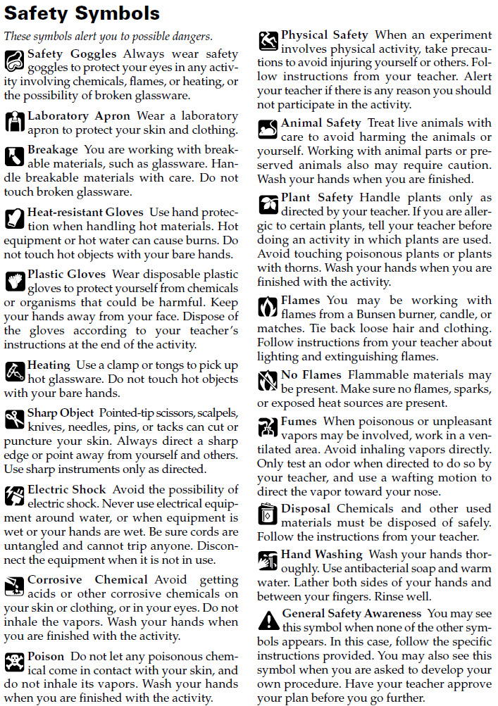
Identifying Safety Symbols
Special symbols may be seen in any science laboratory you visit. Study the Lab Safety Symbols and write what you should be cautious of should you see the below symbols expressed in a lab setting.
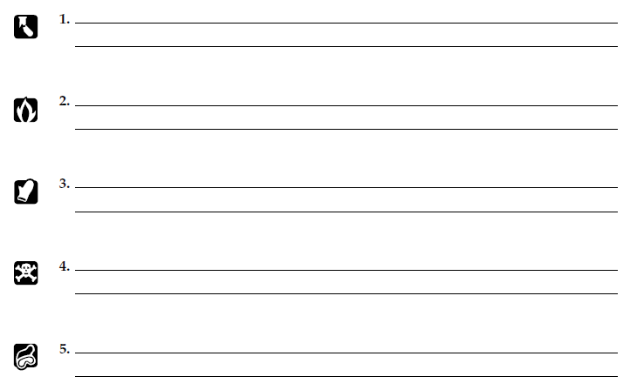

Draw It
Draw what symbol you would use if you wanted to exhibit caution when working with animals?

Questions:
- Why might eating or drinking in the laboratory be dangerous?

- How can reading through the entire investigation before beginning the Procedure help prevent accidents?

- Look around the room. What safety equipment do you recognize?

- What safety procedures should you follow when cleaning up at the end of an investigation?

- Can minor safety procedures be skipped in order to finish the investigation before the bell rings?

Analysis and Conclusions
Look at each of the following drawings and explain why the laboratory activities pictured are unsafe.
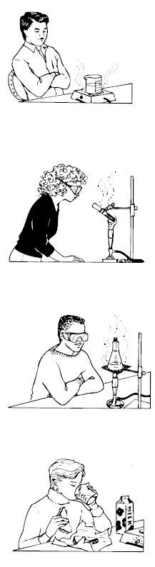
- __________________________________________________________________________________________________________________________________________________________________________________________________________________________________________________________________________________________________________________________

- __________________________________________________________________________________________________________________________________________________________________________________________________________________________________________________________________________________________________________________________

- __________________________________________________________________________________________________________________________________________________________________________________________________________________________________________________________________________________________________________________________

- __________________________________________________________________________________________________________________________________________________________________________________________________________________________________________________________________________________________________________________________

Part 2: Laboratory Equipment
Scientists use a variety of tools to explore the world around them. Tools are very important in the advancement of science. The type of tools scientists use depends on the problems they are trying to solve. A scientist may use something as simple as a metric ruler to measure the length of a leaf. At another time, the same scientist may use a
complex computer to analyze large amounts of data concerning hundreds of leaves. In this investigation, you will identify pieces of laboratory equipment likely to be found in a biology laboratory. You will also learn the function of each piece of laboratory equipment.

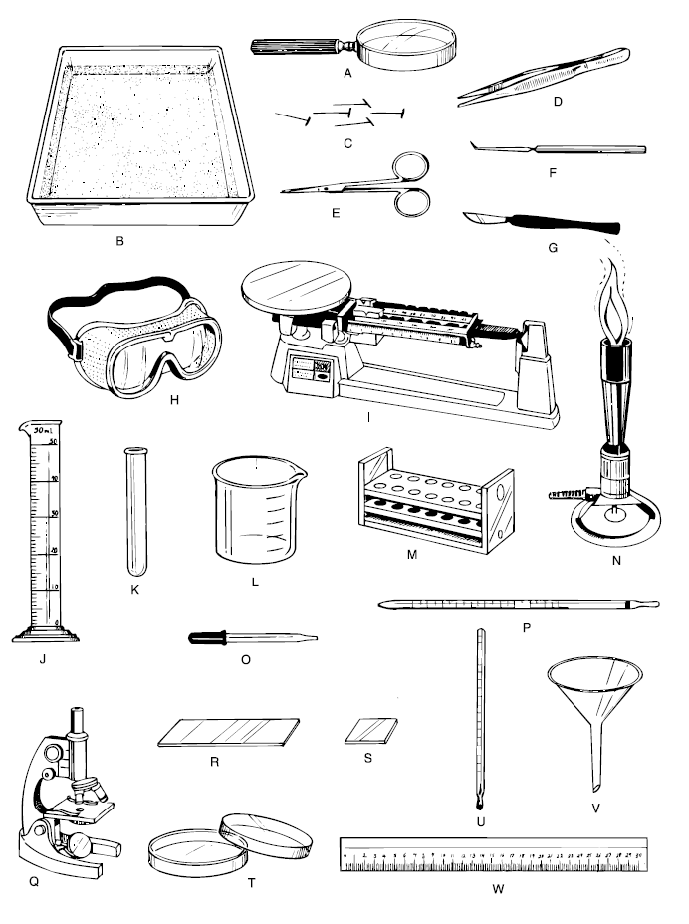
Chart 1: Tools in the Science Classroom

Key:

slide
cover slip
test tube rack
probe
scapel
Bunsen burner
triple beam balance
eye dropper
graduated cylinder
safety goggles
dissecting tray
pins
forceps
dissecting scissors
beaker
magnifying glass
thermometer
stirring rod
test tube
funnel
ruler
microscope
petri dish

Tool Identification
Use the key to identify the tools seen in Chart 1.

- _______________________________
- _______________________________
- _______________________________
- _______________________________
- _______________________________
- _______________________________
- _______________________________
- _______________________________
- _______________________________
- _______________________________
- _______________________________
- _______________________________
- _______________________________
- _______________________________
- _______________________________
- _______________________________
- _______________________________
- _______________________________
- _______________________________
- _______________________________
- _______________________________
- _______________________________
- _______________________________

Discussion Questions
Use your knowledge of lab equipment to answer the following questions.

- What kinds of measurements might you need to make in the laboratory?

- What kinds of equipment would you need for these tasks?

- Which laboratory tools can be used to magnify small objects so they can be seen more easily?

- Which laboratory tools are useful when looking at the internal organs of an earthworm?

- What tool or tools would you use to make each of the following measurements?

- amount of milk in a small glass

- length of a sheet of paper

- temperature of the water in a swimming pool

- mass of a baseball

- How do laboratory tools improve the observations made by a scientist?

The Lab Safety Contract
Signing this contract tells your teacher that you are aware of the rules of the laboratory. Return your signed contract to your teacher. You will not be allowed to work in the laboratory until you have returned your signed contract.

I, ____________________________________________, have read the Safety in the Biology Laboratory and I understand its contents completely, and agree to follow all the safety rules and guidelines that have been established ineach of the following areas: (please check)

Dress Code
Using Glassware Safely
General Safety Rules
Using Sharp Instruments
First Aid
Using Chemicals Safely
Handling Living Organisms
Heating and Fire Safety
End-of-Investigation Rules

Signature______________________________________________________ Date: _____________________

