Name: ______________________________________ Period: ______________ Living Environment

Lab # _____ Flower Structure, Reproduction and Dissection
Part 1: Reading and Questions
Flowers are the plant's reproductive structures. Angiosperms are types of plants that bear fruits and flowers. Flowers are usually both male and female, and are brightly colored to attract insects to help them carry pollen used for sexual reproduction. Not all flowers are colorful, though. These flowers usually use the wind for pollination.

Parts of the Flower
The receptacle is the part of the branch on which a flower forms. Color the receptacle (B) brown. Sepals are leaf like structures that surround and protect the flower before it blooms. Color the sepals (C) green. Petals are the colorful part of the flower that attracts insects and even other small animals, such as mice, birds, and bats. Color the petals (D) a bright color of your choice. All flowering plants have flowers, but some are not brightly colored. The petals of these flowers are reduced or absent and the plant relies on the wind or water for pollination.
The flower has both male and female reproductive parts. The female reproductive structures are called carpels. In most flowers, the carpels are fused together to form a pistil. Color the pistil (P) pink. The pistil has three parts, which can be seen, in the box labeled "pistil". The stigma at the top is often sticky and is where the pollen attaches. Color the stigma (J) purple. The style is the long tube that attaches the stigma to the ovary. Sperm from the pollen will travel down this tube to the ovules. The ovules, or eggs, are stored in the ovary until they are fertilized. Plants can only fertilize eggs of the same species. Special chemicals prevent sperm from fertilizing the eggs of flowers that are not the same kind. Color the style (K) red, and the ovary (L) pink. Color the ovules (O) black.
The male reproductive structures are called the stamens. Color the stamens (H) blue. Each stamen consists of an anther (A), which produces pollen, and a filament (F), which supports the anther. In the box labeled "stamen" color the anther dark blue, and the filament light blue. Pollen produced by the anther is carried by insects or other animals to the pistil of another flower where it may fertilize the eggs.
The other flowers in the picture follow the same plan, although they come in many different colors and styles. Color each of the flowers according to the colors above (blue for stamen, pink for pistil, bright colors for the petals. etc.). Note that in some of the flowers, not all the structures are visible.

Plant Reproduction
Sexual reproduction in plants occurs when the pollen from an anther is transferred to the stigma. Plants can fertilize themselves: called self-fertilization. Self-fertilization occurs when the pollen from an anther fertilizes the eggs on the same flower. Cross-fertilization occurs when the pollen is transferred to the stigma of an entirely different plant.
When the ovules are fertilized, they will develop into seeds. The petals of the flower fall off leaving only the ovary behind, which will develop into a fruit. There are many different kinds of fruits, including apples and oranges and peaches. A fruit is any structure that encloses and protects a seed, so fruits are also "helicopters" and acorns, and bean pods. When you eat a fruit, you are actually eating the ovary of the flower.

Questions
1. What is an angiosperm?
2. The flower attaches to what part of the plant?
3. Why are flowers brightly colored?
4. Name two mammals that might pollinate a plant.
5. If the petals of a flower are reduced or absent, how is the plant pollinated?
6. The female reproductive structures are called the:
7. Name the three parts of the pistil:
8. Where are the ovules stored?
9. Name the two parts of the stamen:
10. Describe sexual reproduction in plants.
11. The ovary develops into what structure?
12. Define fruit.

13. Some flowers are not brightly colored at all, but have a very pungent odor that smells like rotting meat. How do you think these flowers are pollinated?

14. In many flowers, the pistils and stamens reach maturity at different times. Considering what you know about pollination, why would this be an advantage to the plant?

Figure 1: An Angiosperm Flower
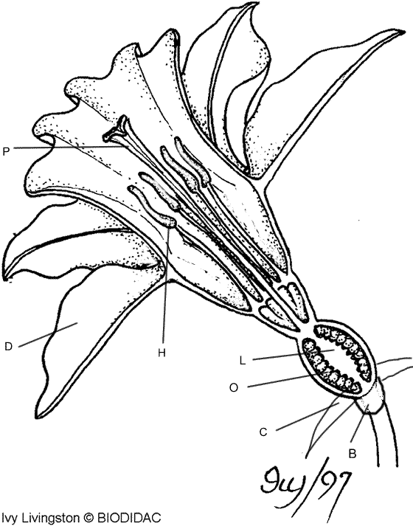
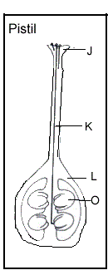
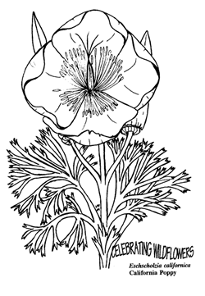
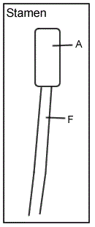
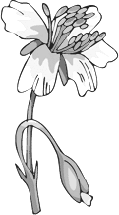
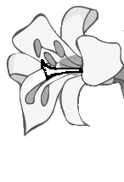

Part 2: Flower Dissection
Procedure: Obtain a flower from your teacher.
Locate males and female parts of the flower. Use Figure 1 as a reference.
Complete Male and Female Flower Parts Dissection

Male Flower Parts Dissection
1. Carefully remove the sepals and then the petals. Try not to remove any smaller parts inside the petals.
2. Use Figure 1 to help you locate the male flower parts:
- Stamen – made up of anther and filament
- Anther – top part of stamen, yellow in color
- Filament – thin stalk that supports flower
3. Count the stamen from your flower, record in Table 1, then write the functions of these flower parts in Table 1
4. Remove one anther, then place it on a glass side.
5. Crush the anther with a pencil eraser. Add two drops of water and a cover slip.
6. Examine the slide under low power, then high power of your microscope.
7. The small round parts you see are pollen grains. Draw them in the field of view below, then, complete Table 1 for Pollen Grains.
Pollen grains

Female Flower Parts Dissection
- Use Figure 1 to help locate the female flower parts.
- Pistil
  - Sigma – top sticky part of pistil
  - Style – tall stalk of pistil, supports stigma
  - Ovary – located at base of pistil
- Count the number of each of the flower parts examined in step 1. Record these numbers in Table 1.
- Write the function of each of these parts in Table 1, then complete the last column of Table 1 for these flower parts.
- Carefully try to cut down the center the pistil and the ovary, then use a magnifiying glass and observe the ovules.

Table 1:
Flower Part | Number of Parts | Function | Male or Female Part? Or Both?
Sepals
Petals
Stamens
Anthers
Filaments
Pollen Grains | Approximately Thousands
Pistil
Stigma
Style
Ovary
Ovules | Approximately  1 to 100

