Name: _______________________________________________________ Period: ___________ Living Environment Lab

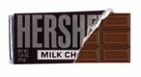
Lab # ______ Density for Chocoholics

Introductory Paragraph: Density is the quantity of something per unit measure, especially per unit length, area, or volume. The denser something is, the more compact it is. For example, a marble will have a higher density than a sponge. The mass of an object tells how much matter is in that object, and the weight is the amount of gravity being exerted on the object. Weights can change, but mass is constant. The density of any substance is always constant when it is under constant conditions of temperature and pressure. Altering the temperature and/or pressure of a system will also alter the density of any substance. The density of most any substance can be determined by measuring its mass and volume and using the following equation:

Density Equation:
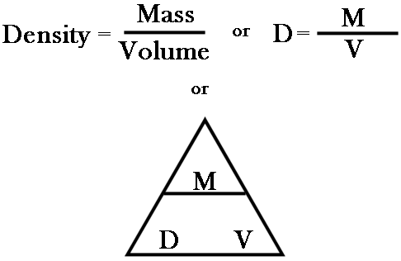

Objective: You will be able to calculate the densities of various sized pieces of chocolate and recognize that density is one of the most important properties of matter.

DEFINE the following vocabulary terms and STATE WHAT TOOLS YOU USE to find each measurement:

- Mass:

- Weight:

- Volume:

IMPORTANT: Record ALL measurements in the report sheet!

Procedure: (DO NOT eat the candy until your mass and volume measurements have been completed and recorded on the report sheet):

What is the Density of a Hershey’s Chocolate bar?

- Unwrap your candy bar without breaking it. It is very important that it remain in one piece for the beginning of the activity.

- Using the triple-beam balance, determine the mass of the candy bar (diagram 1). For sanitary purposes place the candy bar wrapper between the chocolate bar and the balance pan.

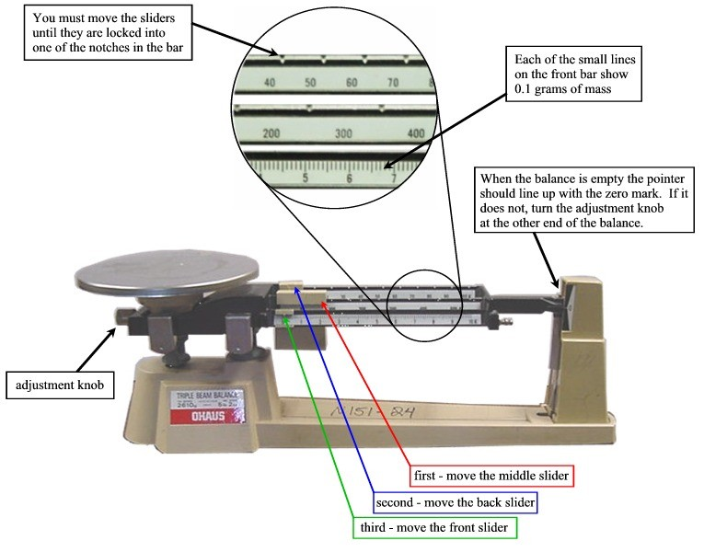

Diagram1:
How to use the triple-beam balance

- Record the mass of the whole Hershey Bar in proper location of the report sheet. Label your units to the nearest tenth of a gram.

- Find the volume of the whole Hershey Bar using a metric ruler and the equation for the volume of a rectangular solid: v = l x w x h. Where v = volume, l = length, w = width, and h = height.

- Record the volume of the whole bar in the proper location of the report sheet. Label the units to the nearest tenth of a cm3.

- Calculate the density of the whole Hershey Bar using the density equation at the top of page 1 and your data from steps 2 and 5.

- Record the density of the whole Hershey Bar in the proper location of the report sheet. Use the proper units and label them to the nearest tenth.

- Carefully break the whole Hershey Bar along the center indentation (diagram 2).

- Use a paper clip to scratch an “A” onto the back of one half and a “B” onto the back of the other half.

- Based on the density measurement of the whole bar (your initial observation), predict (infer) what the density might be for the half bar labeled “A”.

- Record your prediction for the half bar in the report sheet, to the nearest tenth.
Diagram 2: Hershey Bar broken along center indentation

- Calculate the density for half “A” of the Hershey Bar using procedures 2 through 5 from above.

- Record your answer in the report sheet to the nearest tenth.

- Carefully break half “A” along its center indentation (diagram 3) so that you now have 2 quarters of the original bar.
- Using the end of the paper clip, label one of the quarters “1” and the other “2”.

- Based on the density measurements of the whole bar and the half labeled “A”, predict what the density might be for the quarter labeled “1”.
Diagram 3: Hershey Bar broken along indentation
- Record your prediction in the report sheet to the nearest tenth.

- Calculate the density for quarter “1” using procedures 2 through 5.
- Record your answer in the proper location of the report sheet. Label your answer to the nearest tenth.

- Carefully break quarter “1” into thirds along the indentations (see diagram 4).

- Using the paper clip, label the top piece of chocolate bar with an “a”, the center third with a “b” and the last third with a “c”.

- Based on the density measurements for the whole bar, the half labeled “A”, and the quarter labeled “1”, predict what the density might be for the small piece (third) labeled “a”.
Diagram 4: Hershey Bar broken along indentation

- Record your prediction in the proper location of the report sheet. Record your answer to the nearest tenth.

- Calculate the density of the small piece of the Hershey Bar using procedures 2 through 5.

- Record your answer in the proper location of the report sheet to the nearest tenth.

Hershey Bar | Mass (g) | Volume (cm3) | Density (d=m/v)
Whole Bar
Prediction for Half – Bar
Half – Bar Measurements
Prediction for Quarter Bar
Quarter Bar Measurements
Prediction for Small Piece
Small Piece Measurements

Questions:
- How does the density of the whole Hershey Bar compare to the density of the half-bar?

- How does the density of the half-bar compare to the density of the small piece?

- Does your data concur with the introductory paragraph?

- If your data concurs with the introduction then go on to question #5, if not describe why not.

- What effect does the shape and/or size of a Hershey Bar have on its density?

- How would the density of melted (liquid) chocolate compare to the density of the solid bar? See introduction for assistance – think about what is required to make a phase change happen…

- Based on this activity, describe what happens to the density of any substance when the size and/or the shape is changed.

