Name: _____________________________________________________________________ Period: _______________________ Science 7

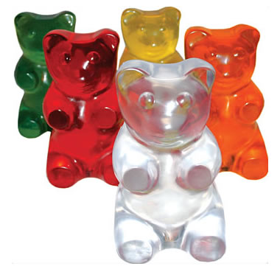
Lab # ______ Gummy Bear Osmosis
Purpose:
To investigate the properties of osmosis and diffusion.

Materials:
For groups of students…

- 3 - plastic cups
- permanent marker
- 3 - Gummy Bears (different colors)
- salt
- tap water
- centimeter rulers

Procedure:
- Obtain three plastic cups, three different colored Gummy Bears, and a ruler.
- On the side of each cup, write your name and class period using a permanent marker.
- Label one cup “CONTROL”, one "TAP WATER" and the other "SALT WATER".
- Measure your bear (in cm) from top to bottom (length) and from side to side (width) and from front to back (height). Record the centimeters in the data table under DAY 1. Use decimals.
- Place the bears in the cups and cover one with tap water and the other with salt water; leave the CONROL empty.
- Place the cups on the counter away from direct sunlight. Let them sit overnight.
- On the next lab day, gently pour water out of the two cups and into a bucket. Catch each gummy bear.
- Once again, measure the length, width, and height for each gummy bear. Record your data under DAY 2. BE CAREFUL not to break the bears, they are very fragile.
- Graph your data and analyze results.
Hypothesis: Write what you predict will happen for each bear (try to use an “if…then…” statement)
Control Bear Hypothesis:

Tap Water Bear Hypothesis:

Salt Water Bear Hypothesis:
Day 1: Pre-Soak
Color of Gummy Bear | Length (cm) | Width(cm) | Height(cm) | Mass (g)
Tap Water Gummy
________(color)
Salt Water Gummy
________(color)
Control Gummy
________(color)
Day 2: Post-Soak
Color of Gummy Bear | Length(cm) | Width(cm) | Height(cm) | Mass
Tap Water Gummy
________(color)
Salt Water Gummy
________(color)
Control Gummy
________(color)
Analysis:
Were your hypotheses correct?

What happened to the gummy bears that soaked in tap water?

What happened to the gummy bears that soaked in salt water?

Define osmosis in your own words? Did osmosis happen with your gummy bears?

